PARENT INFORMATION PACK

Welcome to MiniStars Childcare
”
Luton
“

An exciting & creative way for your child to learn and play.

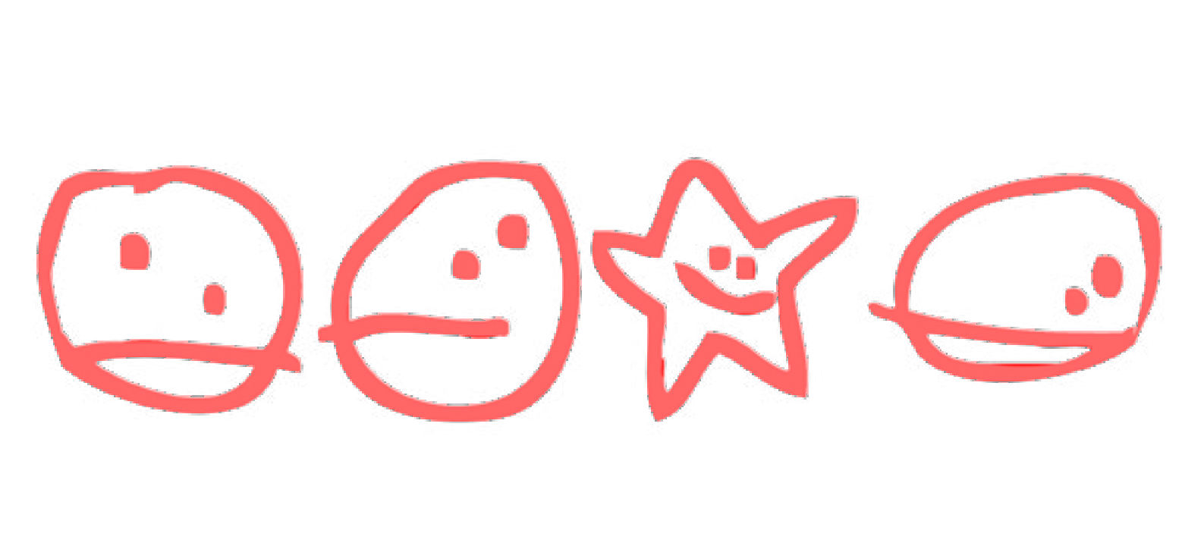Our Vision

Our Mission

Our Purpose
To promote the well-being of every child to live happy, healthy, safe and rewarding lives.

Working together to create genuine opportunities for children and parents, to fulfil their hopes, aspirations and dreams.

To provide the young children placed in our
care with a welcoming, safe, secure, enjoyable, happy and stimulating environment, in preparation for their transfer to infant school. Experience the most natural of environments where your child’s skills are developed, their experiences are widened and their individuality valued.

The MiniStars Childcare Ethos

Each child’s day is carefully planned to enrich their interest in the many areas of the curriculum; encouraging enjoyment whilst learning through play. We aim to care for children in a manner that is relaxed, friendly, stimulating, inspiring and challenging.

Our mission is to provide the children with the confidence to grow and learn at their own pace and in an environment that is safe and secure.

Children are treated with respect as individuals. Our service and delivery are developed and designed around their changing needs. Racial and cultural diversity are recognised and respected. MiniStars Childcare employ highly qualified, committed, experienced and enthusiastic staff that have created a stimulating environment where your child’s first experiences of nursery school is an exciting place to be. This exciting place offers opportunities which allow children to develop their own interests and a love of learning through play.
MiniStars Childcare is an environment where all children and their families are listened to, valued and respected. By working in partnership with parents, community and external agencies, we aim to meet and exceed all of the goals set out in the government standards for childcare and the Early Years Foundation Stage. As we are equipped with high quality resources and equipment we are able to offer a variety of interactive educational experiences based on each individual child’s stage of development, with an emphasis on learning through play challenge and discovery

.

,

Working Together

We believe that being committed to positive relationships with the families of our children ensures the continuity of your child’s development. Your views and experiences of your child are essential to the service that we provide.

Childcare At Ministars

MiniStars Childcare is a private childcare provision
accommodating 33 children aged 6 months to 5 years, with a focus on learning through play and utilizing the many experiences gained from the wonderful outdoors. We strive to ensure that your child will learn, develop and be challenged in natural and diverse ways.

We are a childcare provision which is not just a place for your child to be during the day, but a place where your child will be safe, cared for, and will be completely prepared for the move onto big school.

Imbedded in our activities is the time to allow children to explore and experiment by playing with high quality resources and equipment. Through consistent supervision and interaction with the children we ensure that they feel secure enough to try new ways of examining their surroundings, using all of their senses to learn. Children’s creativity develops most productively within a rich learning environment supported by sensitive and responsive adults. An environment that lets them imitate what they see, experiment with ideas and, more importantly, contribute their own ideas, is an environment where they will achieve the best possible 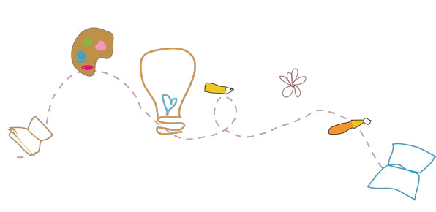outcomes for their age or stage

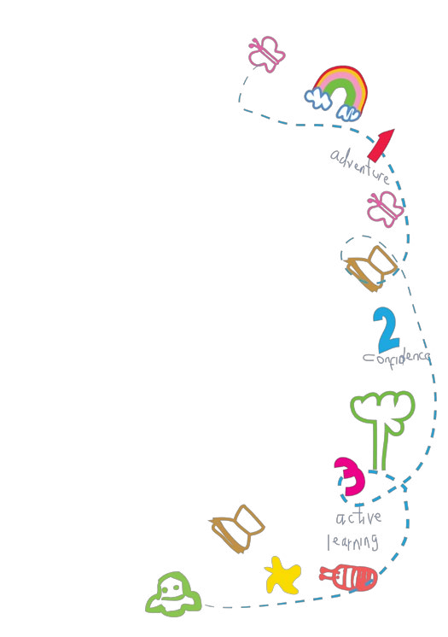The Nursery Environment
MiniStars Childcare is housed in the dynamic UK Centre for Carnival Arts (UKCCA), which is the first centre of its kind dedicated to the professional development of carnival artists in the UK. Our nursery was completed in July 2009 and has environmental sustainability, which was achieved by incorporating hi-tech materials and designs into external and internal fabric of the building design.

We aim to have as much outside play as possible because we believe physical exercise and fresh air is an important part of a healthy lifestyle, this is also the foundation to our healthy eating policy. The varied activities on offer will provide every opportunity to extend and build on physical, intellectual, linguistic, emotional and social skills, enabling the children in our care to reach their full potential.

The indoor environment offers a wonderful feeling of space with lots of natural light pouring through the many windows. There is a vast amount of natural wood, which is the main feature of the internal space, creating a lovely calming environment

The Early Years Foundation Stage (2021)
The Early Years Foundation Stage Framework sets the standards for learning, development and care for children from birth to five.
The Early Years Foundation Stage (EYFS) sets the standards that all early years providers must meet to ensure that
Children learn and develop well and are kept healthy and safe. It promotes teaching and learning to ensure children’s ‘school readiness’ and gives children the broad range of knowledge and skills that provide the right foundation for good future progress through school and life.

Over-arching principles
Four guiding principles that shape our practice at MiniStars Childcare are:.

1. every child is a unique child, who is constantly learning and can be resilient, capable,
confident and self-assured;
2. children learn to be strong and independent through positive relationships;
3. children learn and develop well in enabling environments, in which their experiences respond to their individual needs and there is a strong partnership between practitioners and parents and/or carers; and
4. children develop and learn in different ways and at different rates.

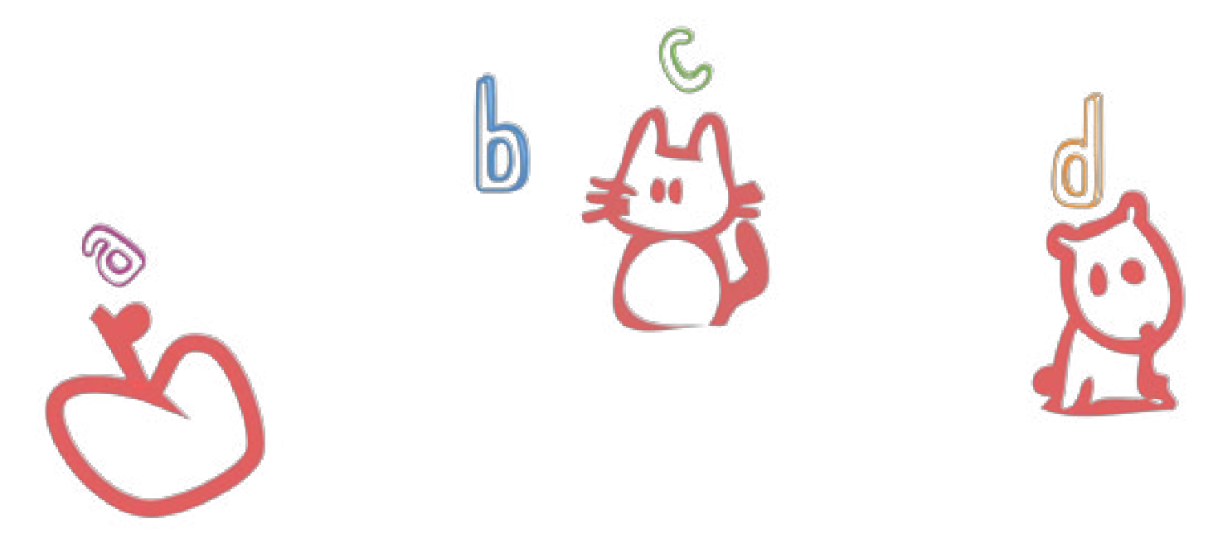The framework covers the education and care of all children in early years provision, including children with special educational needs and disabilities

The Areas of Learning and Development
There are seven areas of learning and development that must shape educational programmes in early years settings.

All areas of learning and development are important and inter-connected.

The three prime areas, are:
- communication and language;
- physical development; and
- personal, social and emotional development.

We also support children in four specific areas, through which the three prime areas are strengthen and applied
The specific areas are:
- literacy;
- mathematics;
- understanding the world; and
- expressive arts and design.

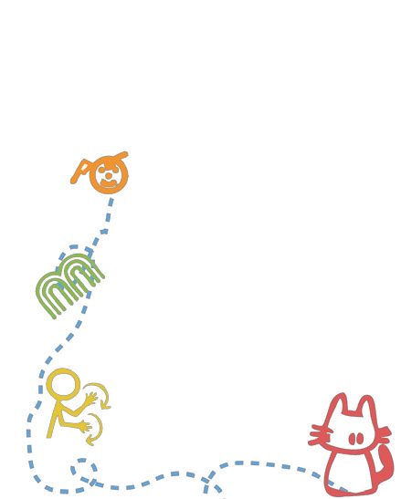

Makaton Sign Language

• Makaton is a key part of our daily routine and registration. The signing is always conducted with the spoken word so it encourages ALL children to develop their communication skills. Since introducing makaton in our setting, we have found that it helps towards reducing children’s frustration as well as building upon their self-esteem. Makaton is also very good at helping those children with SEND or EAL
Essential Information

When first coming into the nursery both you and your child are bound to feel a little overwhelmed and unsure. Please don’t! Always feel you can talk to any member of staff about anything, we will always make time for you, to make these early days here as easy as possible.

We have no set criteria on how to settle individual children; we feel it is important for you to decide how long you wish to stay with your child in or- der to settle them in. please feel free to allow your child to bring with them comforters if you feel this will help them to settle in.

If you bring a buggy please fold it and store it carefully in the buggy shed

If you arrive by car please drive carefully through the carnival arts building as children will be leaving and arriving at all times of the day.

Please do not bring your child to nursery if they are unwell. If they have sickness and/or diarrhea they must be kept home for 48 hours after the last attack.

Please make sure your child has warm clothes and a coat on colder days
for outside play and suitable, supportive shoes. Also please ensure that you provide a hat for sunny days.

Make sure all your child’s clothing and belongings are clearly named.

Please check your child drawer every day and take things home. Please
Do not overload your child’s peg and do not bring plastic carrier bags into
nursery.

If your child wears nappies please remember to supply them together with wet wipes and any creams, and remember to replenish them if staff informs you they are running out.

Please remember we do not open before 8am and our staff finish work at
6pm so please ensure children are collected by this time.

Starting With MiniStars
Entry to nursery
Before starting at Ministars Childcare we must have received a completed Registration form along with the registration fee and deposit. You must be open and honest about history, safeguarding or development concerns you may have about your child/ren to ensure we can put in early support to help your child reach their full potential.

Home Visit
Once we have received your completed registration form, fee and deposit the nursery will arrange a home visit where possible. Conducting home visits helps to form relationships between parents, practitioners and children; and starts the process of sharing information. It helps to develop a relationship and build trust in a more relaxed environment. After a home visit, parents often feel more confident in approaching a practitioner with comments and questions.

Settling in and Induction
Starting nursery whether on a part time of full time basis is a major change in your child’s life. Every effort is made
to ensure a smooth settling in process but, we also understand this can be very unsettling for both you and your child who may not have had any significant time apart.
Evidence has shown the more sessions your child has at nursery the quicker the settling in process becomes but in any case, we do require a minimum settling of 5 sessions over a two week period where possible. These sessions are free of charge as they are to benefit your child.
During these sessions it is your choice of how long you leave/ or stay with your child but a member of staff will recommend what we find has worked best. A parent/carer is required for the first settling in session to complete our parent induction.
During the induction you will be introduced to all staff and our policies and procedures, and what we expect.

Key worker
During the settling in sessions your child will be assigned a key person. The key persons role is to help and ensure that every child’s care is tailored to meet their individual needs, to help the child become more familiar with the setting, offer a settled relationship for the child and build relationships with their parents. Please feel free to speak to your child’s Key Person or any other staff member at any time regarding anything at all - if it is important to you it is important us.

Accidents and Incidents
Unfortunately accidents do sometimes happen at nursery even though we try to prevent them. All accidents are recorded on an accident form, which tells you what has happened, where it had happened and how the child was. You will be asked to sign this form when you collect your child as well as the person who dealt with the accident and the nursery manager in charge that day. In the event of a serious accident taking place we will contact you immediately to advice you of the event and what action has been taken.

Illness and medicines
In order to maintain a healthy environment, children should be kept at home if unwell. Minor coughs and colds will not exclude attendance at nursery, as long as the child is well enough to cope with the nursery day. Nursery will administer prescribed medicines only. The appropriate forms must be completed and signed by the parent/carer and the medicine MUST have a prescription attached. At MiniStars Childcare we follow the ‘Guidance on infection control in schools and other childcare settings’ to ensure we follow the correct exclusion periods for illnesses.
If your child is ill and cannot attend Nursery you will still be charged FULL FEES.

Care Plans
If your child has a long term illness including eczema, asthma or allergies a care plan will be filled out with you to make sure staff are fully aware of any medication, signs and symptoms to look out for. We also require a medical report from the doctors to back up the care plan.

Transitions
If you child moves form the baby room up to the preschool room a full transition will be planned similar to the settling in sessions they had when they stated. A transition plan will be completed by current key worker and the transition will last a maximum of 4 weeks. The original key worker will accompany the child over to the Pre-School room to help them settle in. When your child is leaving us to go to school we will invite the school in to meet your child and go through their profile and discuss any concerns we may have
What You Need To Provide

Twinkle Stars: 0-2

• You will need to bring in enough nappies and wipes for your child each day and any nappy creams your child may have. Please ensure all of this is clearly named.
• An unopened can of Formula milk or clearly labelled breast milk which will be stored in the milk kitchen.
• At least two spare sets of clothes including socks and vests in a named bag please
• Any comforter your baby may have during the day for example a dummy, special teddy bears etc
• Your baby will be provided with a cot/bed sheet and blanket that will be washed weekly or more if needed

Bright Stars and Superstars: (2-3’s and 3-5’s)

- Spare clothes including socks and vests with clear name labels please.
• If your child is toilet training please supply plenty of changes of clothes and remember to take soiled or wet clothing home at the end of the day. Nursery staff will let you know how the toilet training went each day.
• Suitable clothing as we like to spend as much time outside as possible, even during the colder months, please ensure your child has suitable clothing for example hats, gloves, suitable shoes.
• During the summer months you will need to supply
a sunhat which gives protection of the face and neck and a named bottle of sun – cream if you choose to provide your own.
• Please remember that children enjoy having fun and getting messy, and although we do encourage them to wear any apron during all messy activities we do advise that you do not send your child to nursery in “best clothes”.
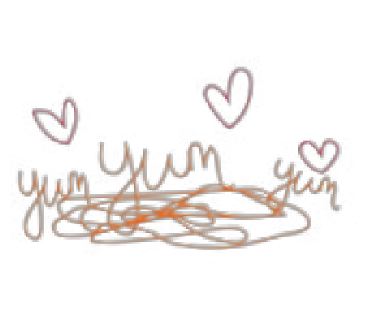

Healthy Eating and Good Oral Health
At Ministars we follow the Family Food First guidance along with The Children’s Food Trust, following the
Eat Better, Start Better Programme as well as the Healthy Smiles award. In line with this guidance we offering
a ’special of the day’ for breakfast (20%) alongside their usual choice of cereals and toast.
Morning snacks (10%) are a variety of healthy snacks with a choice of milk of water. Lunch (30%) consist
of a hot dish with a pudding.

At 2pm the children have another small snack (10%) alongside their usual choice of milk or water
Tea time (20%) meals are a large two course snack.

The guidance sets out that during the nursery day children will be having 90% of their nutrient requirements so in the evening it is recommend that children are having a snack to make up the other 10%. These percentages are based on the idea that children need to eat more regularly during the day as that is when they are using most of their energy. The food is freshly prepared and homemade which has a balance of protein, dairy, carbs and fruit and vegetables. We recognise our influence on children’s food intake and eating behaviour and we encourage our children to try new foods and to sit down at the table and share food together. The older children are encouraged to serve themselves and tidy away their dishes.

The children have independent access to water throughout the day.
We have a set menu which will include a vegetarian option but if your child has
allergies then we will produced an individual menu to suit their
dietary needs.

Allergies

Before your child starts we will discuss any allergies that your child may have. If your does have allergies then we do require a medical report from the doctor.
As our food is freshly prepared each day, the
Chef can accommodate all allergies.
The chef will try and make the food look as similar as possible as what the other
children have.
Sample Menu

Week 1 | Monday | Tuesday | Wednesday | Thursday | Friday
Breakfast | Crumpets | Beans and toast | Bagels | Toasted muffins | Pancakes
Morning snack  Dairy Free Option | Fruit Bowl with mixed fruit | Crackers with cheese  spread  Crackers with soya  spread | Fruit Bowl with mixed fruit | Cheese chunks, breadsticks and pineapple  Breadstick, pineapple | Fruit Bowl with mixed fruit
Lunch  Vegetarian option | Fish Risotto with broccoli  Pepper Risotto with  Broccoli | Sausage with onion Gravy, mash potato and green beans  Vegetarian sausages with onion gravy, mash potato and green  beans | Cheese and leek mac- aroni with sweetcorn  Tomato and leek pasta  with sweetcorn | Chicken casserole with dumplings and mixed vegetables  Three bean casserole with dumplings and mixed vegetables | Vegetable Pizza with potato wedges, salad and coleslaw
Pudding  Dairy Free option | Passion fruit in plain yoghurt  Jelly fruit pot | Jam roly poly and custard | Peaches and Cream  Jelly fruit pot | Frozen yoghurt  Fruit Sorbet | Blueberry muffin
Afternoon snack  Dairy Free Option | Brushetta with chopped tomato’s and red onion | Fruit bowl with mixed fruit | Pitta Bead with tzatziki | Fruit bowl with mixed fruit | Rice cakes
Tea | Cheese scones with clotted cream | Potato skins with  cheese and chive dip | Vegetable quiche with baguette slice | Tuna or egg sandwiches | Cheese and onion pastry swirls
Pudding | Grapes | Oranges | Apples | Pineapple | Kiwi

What To Expect
This guide is to give you information on what to expect when your child starts nursery and how you can help.

• Getting used to separation. If your child isn’t used to being apart from you it can take many
weeks for your child to settle depending upon how many sessions your child has. Children have no
concept of time and will not under- stand that you may only be apart for a short time. You may feel that tears mean your child is unhappy at nursery but, usually, the opposite is the case. The tears are just for you. Children soon stop crying once you have left the nursery as they become occupied with activities and others around them. However, do not be surprised if your child cries when they see you again! If you are concerned you can call the nursery to check your child throughout the day.

• Sleeping patterns will usually change when your child starts nursery. We do have set sleep times
for over 2’safter lunch time but for babies we endeavor to follow your home routines. Your child will typically
be more active at nursery and so may be tired when they return home. At your first settling in session
we will discuss with you our routines so we can ensure consistency for your child. To help with sleep at the nursery you can bring something belonging to your child in to help them settle e.g. a comforter that smells of home.

• Dress code. Dress them in comfy clothes and make sure they can pull clothing down or up easily when they go to the toilet. Clothes will inevitably become dirty through your child’s involvement in activities. Please provide spare clothes –and please label everything.

• Eating. MiniStars Childcare prides itself in the quality and variety of food provided to children in our care. There are routines around meal and snack times which may differ from what the child has experienced at home. Every child will be seated at meal times and taught to use cutlery. The food may differ from home and together with a whole change of lifestyle during the early days at nursery your child may initially eat less. At the settling in sessions we will provide you with full details of our menu for your Childs age group and ensure we understand any allergies or special dietary requirements your child has.

• Behaviour. Your child may experience some anxiety through being separated for the first time. While your child is settling in you may experience attention seeking behaviour or they may be generally irritable due to tiredness. If you are potty training you may experience the odd accident which can be a result of separation anxiety or too engrossed in the activities.

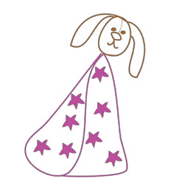• Language/Culture: You will notice your child will start to use and become familiar with key words used at the nursery that may differ from words used at home e.g. toilet, tired and hungry. In our multicultural society or if you are on assignment from overseas English may not be your families first language. At the nursery we do communicate in English but, we can if you wish also use incorporate words provided by yourselves in your families’ native language for key tasks and objects. As part of the settling in process we will seek to understand your language requirements and any festivals celebrated.

Talk about it!
Don’t pretend it’s not happening. The
more you talk about nursery, the easier it will be. Walk past it so your child knows where it is, and what they will be doing here.
Our Daily Routine

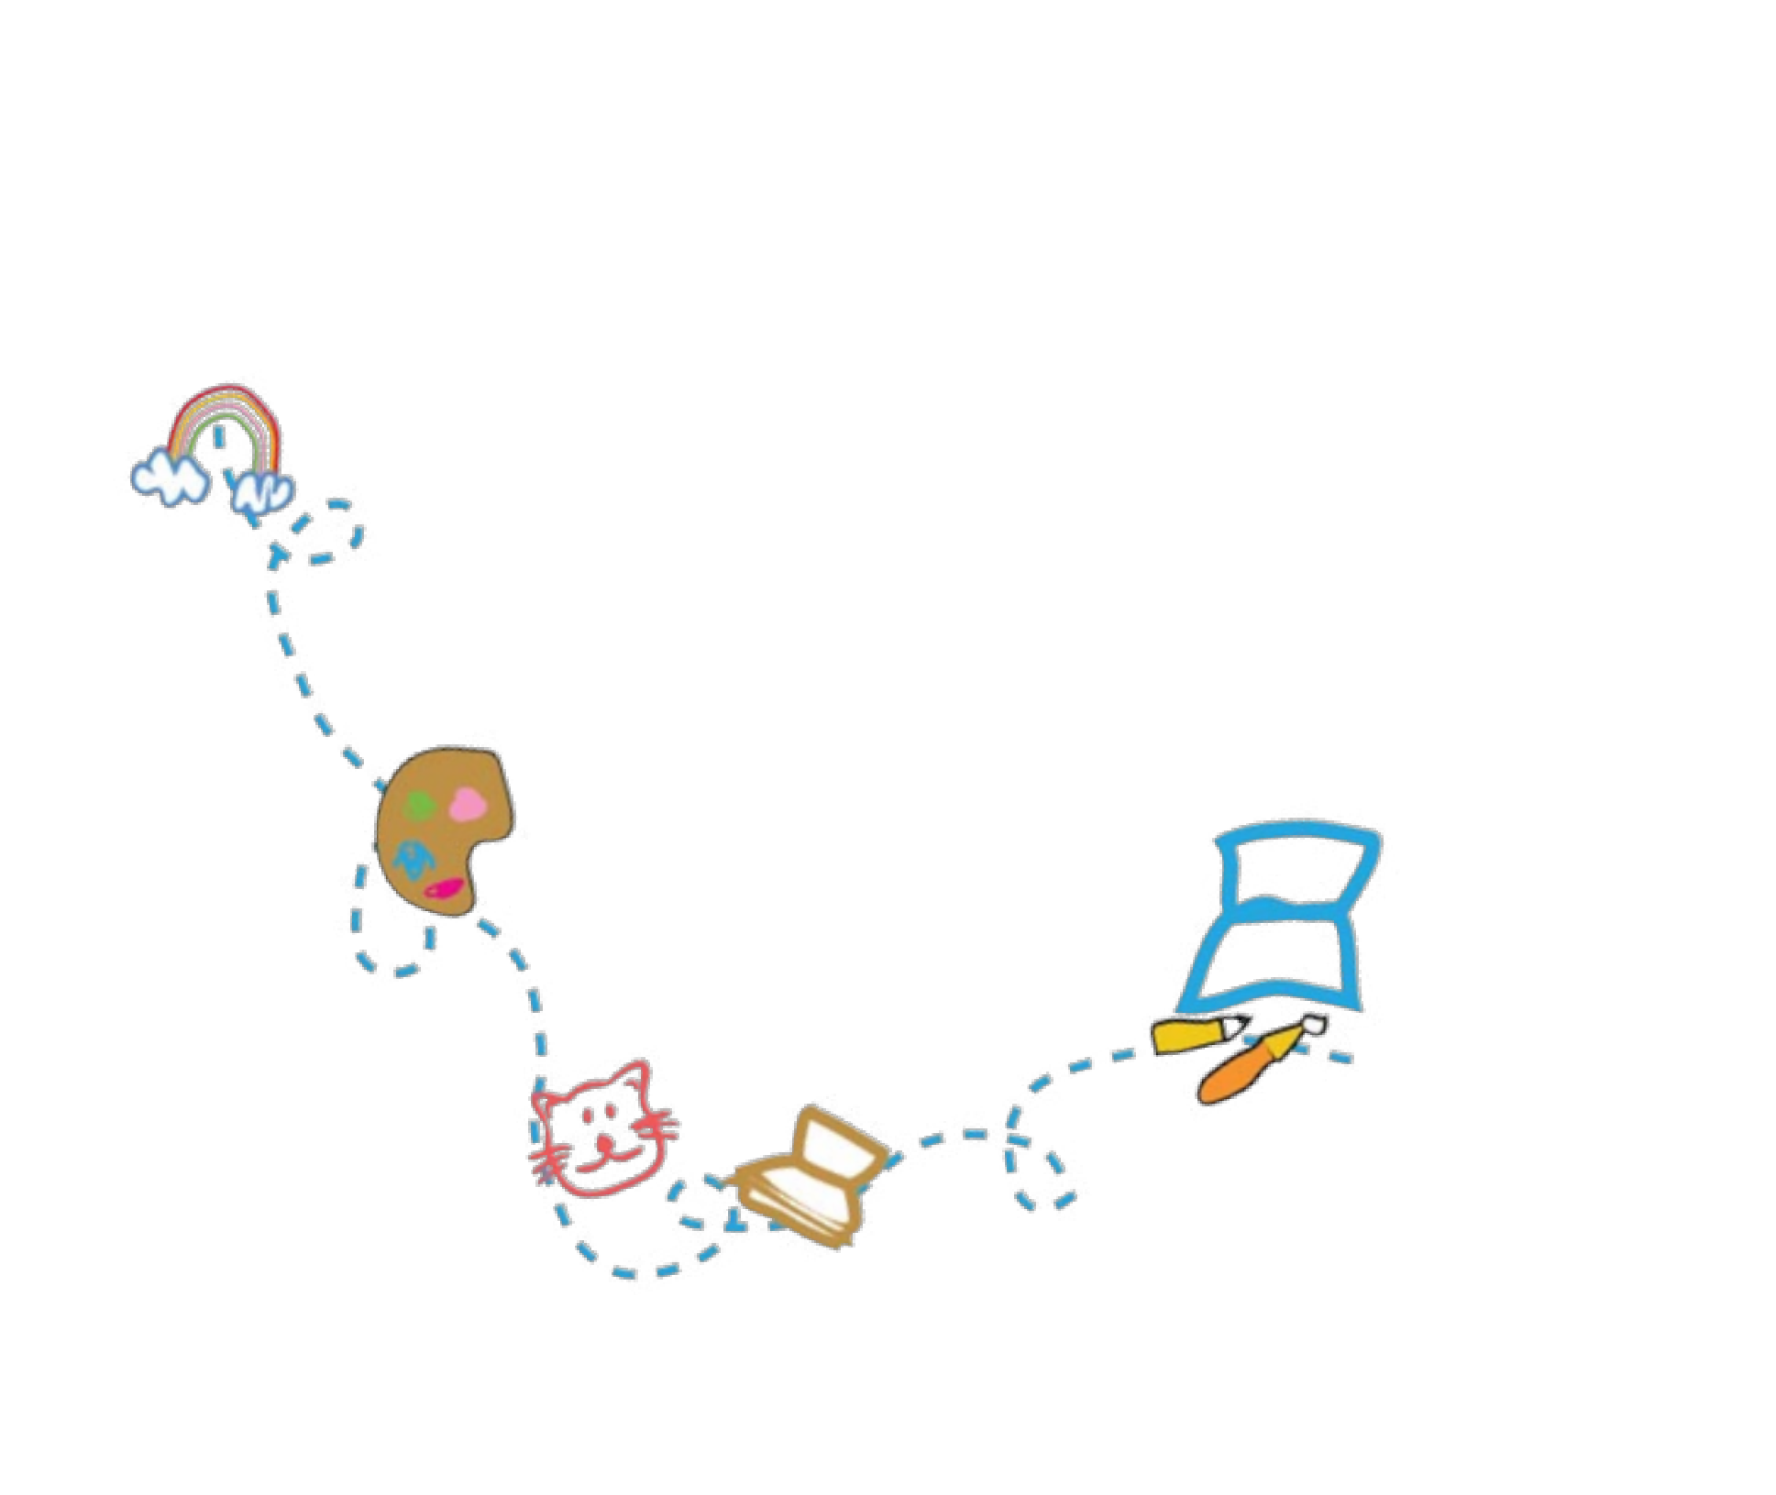

08:00 am-9.00am | Breakfast
8.00-11.15 | Continuous Provision
09:30am | Garden Doors Open
10:00am | Snack
11am | Nappy Changing/toileting
11:30am | Group Time
11:45 – 12:15 | Wash hands and Lunch Time
12:15pm | Sleep time and quiet activities/outdoor play
1.00pm | Morning session ends/Afternoon session starts
1.00pm | Continuous Provision
2.00pm | Snack
3pm | Nappies/toileting
3.30pm | Group Time
3.45pm | Tea
4.15pm | Physical/group activities
4.30pm | Activities/free flow
5.30pm | Winding down time
6pm | Home Time

Pricing and Terms for Private Full Day Care

MiniStars Childcare is open 50 weeks per year, Monday to Friday, excluding all bank and statutory holidays, between the hours of 8:00am and 6:00pm. The nursery will be closed for two weeks; one week for Christmas and one week during the month of August. You will not be charged for these weeks.

Registration Fee:
Your child’s name will be entered on the waiting list when a completed registration form and registration fee of £50 (non-refundable) is paid.

Deposit:
A deposit of £150 must be enclosed with the enrolment form to guarantee a space for your child. The deposit will be offset against the final fees at the time of leaving. However, should you cancel your child’s place before the agreed start date or leave the nursery without giving the 1 months’ notice period then this deposit will NOT be refunded. If you are attending a funded only space you will not need to pay a deposit or registration fee

Payment of Fees:
Fees are charged at the rates indicated below and are payable strictly in advance on the first of each month by standing order. A standing order mandate will be sent to you once you have registered your child with us. You may pay fees weekly, subject to prior agreement with the Manager. If you do have permission to pay weekly, fees must be paid every week on the first day your child attends. If payments are not kept up to date the weekly facility will be withdrawn.
Please ensure that fees are paid by the due date, as you will be invoiced if we do not receive payment on time. Late payment of fees will incur a surcharge of £20.00 if not received by the 3rd day after the fee is due. Admissions may be refused in the case of arrears.

Absence:
If your child is absent from the nursery due to family holidays, sickness or any other reason, full payment is still required and no refunds can be given. Fees are due in advance and for the duration of any holidays. Please call and inform the nursery of your child’s absence
Late collection will automatically incur additional charges of £5.00 for every 15 minutes after the due time.

Leaving Notice or Reduction of Sessions:
One month’s notice is required in writing should you decide to leave the nursery for any reason. You will be required to do the same should you decide to reduce the number of days/sessions you child attends. If you wish
to change the days/ or sessions your child attends or attend extra sessions then a ‘Change of hours form’ must be completed and approved by the manager or deputy.

Annual Fee/Review:
There will be an annual review of fees in January and you will be notified of any changes, if applicable, which will take effect two months in advance.
It is understood that on completion of an enrolment form, you are therefore in agreement with the terms and conditions and must abide by them as outlined in this prospectus. This forms the nursery/parent agreement contract.
Funded sessions

At Ministars we offer 15 (2,3 and 4 year olds) and 30 hours (3 and 4 year olds) (eligibility criteria applies) a week free government funding. This funding is for 38 weeks of the year, term time only or we can spread the funding over the 50 weeks we are open which will result in a discount of your monthly fee’s. If you
wish your child to attend for the 15 or 30 hours only then the deposit does not apply. If your child is attending
over their funded hours then the deposit will still need to be paid before starting nursery

Eligibility
All children are eligible for this funding the term after their 2nd or 3rd Birthday. See below for details:

A child born on or between: | Will become eligible for a free place from:
1st April and 31st August | 1st September following 2nd/3rd Birthday
1st September and 31st December | 1st January following 2nd/3rd Birthday
1st January and 31st March | 1st April following 2nd/3rd Birthday

15 hour funding options- Term time only
5 sessions for 3 hours | 3 sessions for 5 hours
9am-12am (morning session) | 8am-1pm (Morning session)
1.30pm-4.30pm (afternoon session) | 1pm-6pm (afternoon session)
30 Hour options- Term time only
3 full days per week | 8am-6pm
5 days per week | 9am-3pm

Additional costs:
There is an additional cost of £3 per day for lunch and snacks if attending 15 or 30 hours funding, or you may provide a healthy packed lunch for your child. Please see section on ‘Free School Meals’ to see if you may be
eligible for this
*please note: if your child attends nursery for 49 weeks of the year and you’re paying a reduced fee
then you will not have to pay for lunch.

*If your child does not regularly attend for the allocated 15 hours then they may be asked to leave
Ministars and they space allocated to another child on the waiting list.

Free School Meals:
Free school meals are only available for 2, 3 & 4 year old children whose parent/guardian is in receipt of a qualifying benefit and where the child is attending a school or a private or voluntary provider, (e.g. pre-school, nursery, childminder), for their free early education entitlement and who attend free provision that includes the lunch period). Please visit https://www.gov.uk/apply-free-school-meals/luton to see if your child is eligible for free school meals.

Is your child two?
Your two year old could get 15 hours a week of free childcare, from the term after they turn two, if you receive any of these benefits:
- Universal Credit
- Income support
- Income based Jobseekers Allowance
- Income related Employment and Support Allowance (if you are unable to work due to illness or disability)
- Support under Part VI of the Immigration and Asylum Act 1999
- The guaranteed element of State Pension Credit
- Child Tax Credit and earn £16,190 or less per year
- Working Tax Credit and earn £16,190 or less per year
- The Working Tax Credit 4-week run on (the payment you get when you stop qualifying for Working Tax Credit)
- Or your child:
- Has a current statement of special educational need (SEN) or an Education, Health and Care plan
- Receives Disability Living Allowance
- Has left care through special guardianship, adoption or residence order
- Is looked after by the local authority
To see if your eligible please visit: https://emsonline.luton.gov.uk/CitizenPortal_LIVE/Account/Login?ReturnUrl=/CitizenPortal_LIVE/

*The times and sessions outlined above also apply for 2 years old funding.

- and 4 year old funding:
15 hours:
- For all families in England with 3 and 4-year-old children
- 15 hours of free childcare or early education for 38 weeks, from 1 January, 1 April or 1 September following your child's 3rd birthday.
- A total of 570 hours per year, that you can use flexibly with one or more childcare provider
- We will allow you to stretch the hours over the 50 weeks we are open
What isn't covered?
The 15 hours free childcare/early education offer does not cover the costs of meals, other consumables,
additional hours or additional activities (such as trips). We may charge a fee for these additions. If you choose
to pay for these you will receive a contact of terms and conditions which must be adhered to. However, you
are not be required to pay any fee as a condition of taking up a 15 hours place.

30 Hours:
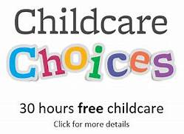
- For working families in England
- With 3 and 4-year-old children
- 30 hours of free childcare or early education for 38 weeks
- A total of 1,140 hours per year, that you can use flexibly with one or more
childcare provider
- We will allow you to ‘stretch’ the hours over the 50 weeks we are open
Am I eligible?
You, and any partner, must each expect to earn (on average) at least £131 per week (equal to 16 hours at the National Minimum or Living Wage).
If you, or your partner, are on maternity, paternity or adoption leave, or you're unable to work because you
are disabled or have caring responsibilities, you could still be eligible.
You can't get 30 hours free childcare if either you, or your partner, each individually expect to earn £100,000
or more.

When can my child start?
Your child can start in their childcare place the term after they turn 3 years old and have received a valid 30 hours code, whichever is later. Term start dates are 1st September, 1stJanuary and 1st April.

To keep your 30 hours free childcare place you need to check your details are up to date every 3 months.

What isn't covered?
The 30 hours free childcare/early education offer does not cover the costs of meals, other consumables,
additional hours or additional activities (such as trips). We may charge a fee for these additions. If you choose
to pay for these you will receive a contact of terms and conditions which must be adhered to. However, you
are not be required to pay any fee as a condition of taking up a 30 hours place.
To see if your eligible please visit: www.childcarechoices.gov.uk

Tax Free Childcare
You could get an additional £2000 per year towards childcare costs
- For working families, including the self-employed, in the UK
- With children under 12 (or under 17 if disabled)
- For every £8 you pay in, the government will add an extra £2, up to £2,000 per child per year
If you're a working parent with children under 12 (or under 17 for disabled children), you can open an online account to pay towards your childcare costs
The government will top-up the money you pay into the account. For every £8 you pay in, the government will add an extra £2. You can receive up to £2,000 per child per year - that's up to £500 every three months. If you have a disabled child, you can receive up to £4,000 per child - that's up to £1,000 every three months.
You can use Tax-Free Childcare at the same time as:
- 15 hours free childcare
- 30 hours free childcare
You can't use it with:
- Universal Credit
- Tax Credits
- Childcare Vouchers
To see if your eligible please visit: www.childcarechoices.gov.uk

Childcare Vouchers

We also accept a wide range of employee childcare vouchers. Please see to your employer to see if they off the childcare voucher scheme

Booking Sessions
Ministars charges a daily rate or half day rate but a minimum of 2 full days or 4 half sessions is required, unless doing funded hours.

Daily Rate

 | 8am-6pm | 8am-1pm or 1pm-6pm
Under 2’s | £60 | NA
2-5’s | £56 | £30

Monthly Rate

Requirement | Under 2’s | 2-5’s (without funding)
5 days | £1225 | £1143.33
4 days | £980 | £914.67
3 days | £735 | £686
2 days | £490 | £457.33

Monthly Rate with 2 and 3+ Funding (49 weeks of the year)

Requirement | 3 and 4 year old minus 30 hours | 3 and 4 year old minus 15 hours | 2 year old minus 15 hours
5 days | £699.68 | £921.50 | £884.54
4 days | £471.02 | £692.84 | £655.79
3 days | £242.35 | £464.17 | £427.12
2 days | N/A | £245.50 | £198.45

UK Centre for Carnival Arts,
St. Mary’s Road,
Luton LU1 3JA
Tel: 01582 437 121
Email: info@ministars-childcare.co.uk
Website: www.ministars-childcare.co.uk
Ofsted Registration Number: EY396927

Recommendations

“I’m so happy I found MiniStars. They have been exactly what my daughter needed. I have been supported through my daughter’s speech delay and nappy training to levels that I was not expecting. I cannot thank the staff enough for the fabulous job that they have done and are still doing with my child. When I thought of my child starting school I had concerns as she was developing and interacting where school life seemed impossible. However I have seen a vast improvement in my daughters behaviour, education and social skills that I am now confident that she is ready for school, which I have no doubt is due the hard work and dedication of the staff and programmes at MiniStars.”

“we all love nursery. My child is so happy here. If we ever had another child we would definitely bring them to
MiniStars. I recommend it to everyone.”

“I believe my child has grown in confidence whilst she has been at nursery. More sociable, better eating habits. And I’m happy they check her development levels.”

“I looked at quite a few nurseries before visiting MiniStars. As soon as I walked into the light and airy space I knew this was the place for me. The nursery is purpose built and open plan not like some of the dark converted houses I had previously visited. The manager put me at ease and offered a settling in plan which meant me and my baby were both very happy. He has been extremely happy at the nursery and settled into the routine immediately. The day is well structured with lots of activities (indoor and out)
I cannot speak highly enough of Ministars and would recommend them to anyone looking for childcare in Luton.”

“Was very nervous about putting my daughter into nursery but MiniStars made it easy and pain free. All the staff are extremely friendly and it is clear to see how much they adore the children. I cannot believe how much my daughter has come on since attending the nursery. She is also happy there and often comes home with lots of works of art. The meals are very varied and makes our meal times easier. I have and will continue to recommend Ministars to anyone, fantastic nursery with fantastic staff.”

Thank you for taking the time to view Ministars Childcare and taking time to read this booklet. If you would like your child to join Ministars Childcare then please return the registration form and deposit (if applicable) and your child will be added to the waiting list. We look forward to hearing from you

The Ministars Team

